**How to activate the Drawer**

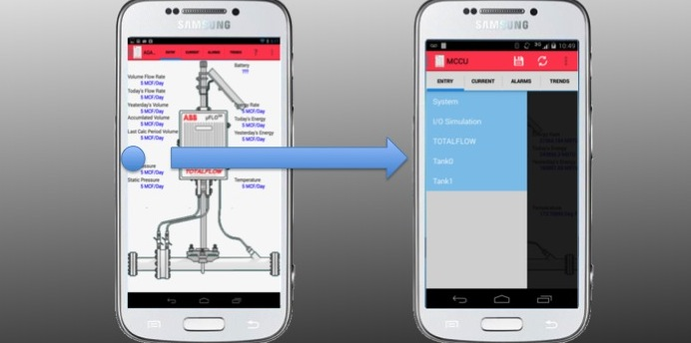

To change applications from the Data View page or the Settings page, hold and drag your finger from the left side of the screen to the right side of the screen. A box will slide out with the applications available for selection.